**Online Residence Portal**

Project Plan

By

Nutdanai Ngoyphuthorn 552115023

Tanawan Fuangthura 552115031

Project Advisor

Dr. Chartchai Daungsa-ard

Department of Software Engineering

College of Arts, Media and Technology, Chiang Mai University

|  |  |  |  |  |  |  |
| --- | --- | --- | --- | --- | --- | --- |
| Document Name | Version | Status | Date | Viewable | Editable | Responsible |
| Documents | | | | | | |
| [Online Residence Portal] Project Plan.doc | [Online Residence Portal] Project Plan 0.9.20150710 | Draft | 10/07/2015 | PM,  SA,  DEV,  QA,  Tester,  Advisor | PM | Mr. Nutdanai Ngoyphuthon  Miss. Tanawan Fuangthura |
| [Online Residence Portal] Project Plan.doc | [Online Residence Portal] Project Plan 0.9.20150724 | Draft | 17/07/2015 | PM,  SA,  DEV,  QA,  Tester,  Advisor | PM | Mr. Nutdanai Ngoyphuthon  Miss. Tanawan Fuangthura |
| [Online Residence Portal] Project Plan.doc | [Online Residence Portal] Project Plan 0.9.20150724 | Draft | 24/07/2015 | PM,  SA,  DEV,  QA,  Tester,  Advisor | PM | Mr. Nutdanai Ngoyphuthon  Miss. Tanawan Fuangthura |
| [Online Residence Portal] Project Plan.doc | [Online Residence Portal] Project Plan 1.0 | Released | 28/07/2015 | PM,  SA,  DEV,  QA,  Tester,  Advisor | PM | Mr. Nutdanai Ngoyphuthon  Miss. Tanawan Fuangthura |

**Chapter one | Introduction**

* 1. **Identification**

This document is a Project Management Plan for Online Residence Portal based on ISO/IEC 29110 –Software Life Cycle Profile and Guideline for VSE to establish and carry out in a systematic way the tasks of the software implementation project, which allows complying with the project‘s objectives in the expected quality, time and costs.

This project plan is the document for planning, scheduling activities and evaluating overall of the project so that the project will complete as successfully as possible in spite of all the risk.

* 1. **Document Overview**

The purpose of the online residence portal project plan is to guide the project team members during the development of the project.

**Progress report l** consist of

**URS-01:** User can register to the system.

**USR-02:** User can login to the system with username and password.

**URS-03:** User can request password via e-mail when the user forget password.

**URS-04**: User can edit their own profile.

**URS-05:** User can view their own profile.

**URS-06:** User can log out from the system.

**URS-07:** User can delete their own account.

**URS-08:** User can post an apartment classified

**URS-09**: User can edit an apartment classified

**URS-10**: User can delete apartment classified

**URS-11:** User can update available status

**Progress report ll** consist of

**URS-12**: User can search apartment.

**URS-13:** User can choose to view apartment search result form.

**URS-14:** User can make an apartment comparison.

**URS-15:** User can save the better apartment to be favorite apartment.

**URS-16:** User can add new apartment to make comparison with the favorite.

**URS-17:** User can calculate total rental fee.

**URS-18**: User can mark apartments to be favorite apartment.

**URS-19:** User can delete apartments in favorite list.

**URS-20:** User can sent private message to other members of the system.

**URS-21:** User can comment in each apartment classified post.

**URS-22:** User can reply comments.

**URS-23:** User can edit their comments and replies.

**URS-24:** Administrator has to login to the system.

**URS-25:** Administrator can log out from the system.

**URS-26:** Administrator can report member.

**URS-27:** Administrator can delete post.

**URS-28:** Administrator can delete comment.

* 1. Deliverable

|  |  |  |  |
| --- | --- | --- | --- |
| Deliverables/Release | Media | Copies | Date |
| Project Proposal  -Online Residence Portal Proposal version 1.0 | Document | 3 | 17th July 2015 |
| Progress Report l  -Project Management Plan version 1.0  -Software Requirement Specification version 1.0  -Software Design Document version 1.0  -Test Plan version 1.0  -Traceability Record version 1.0  -Software version 1.0 | Document  Document  Document  Document  Document  Source Code | 3  3  3  3  3  1 | 29th July 2015 |
| Progress Report ll  -Project Management Plan version 2.0  -Software Requirement Specification version 2.0  -Software Design Document version 2.0  -Test Plan version 2.0  -Traceability Record version 2.0  -Software version 2.0 | Document  Document  Document  Document  Document  Source Code | 3  3  3  3  3  1 |  |
| Show Pro Event  -Software version 2.0  -30 seconds Video  Poster size A1 | Files  File  Poster | 1  1  1 |  |

* 1. **Acronyms and Definitions**
     1. **Acronyms**

ORP Online Residence Portal

SRS Software Requirement Specification

SDD Software Design Document

OS Operating System

VSE Very Small Entity

PM Project Management

SI Software Implementation

ID Iterative Development

SCI Software Configuration Item

* + 1. **Definition**

Feature Transformation of input parameters to output parameters based on a specified algorithm. It describes the functionality of a product in the language of the product. Used for requirements analysis, design, coding, testing or maintenance.[IEEE90]

IEEE Institute for Electrical and Electronics Engineers. Biggest global interest group for engineers of different branches and for computer scientists.[IEEE90]

Plan A documented series of tasks requires meeting an objective, typically including the associated schedule, budget, resources, organizational description and work breakdown structure. [IEEE90]

Project Plan A formal, approved document used to guide both project execution and project control. The primary uses of the project plan are to document planning assumptions and the decision, to facilitate communication among stakeholders, and to document approved scope, cost, and schedule baseline. [IEEE90]

Project Management The application of knowledge, skills, tools, and techniques to project activities in order to meet or exceed stakeholder needs and expectations from a project. [IEEE90]

Risk An uncertain event or condition that, if it occurs, has a positive or negative effect on a project’s objectives. It is a function of the probability of occurrence of a given threat’s occurrence. [IEEE90]

Risk Management The systematic application of management policies, procedures and practices to the tasks of identifying, analyzing, evaluating, treating and monitoring risk. [IEEE90]

Traceability The ability to trace the history, application or location of an item or activity, or work products or activities, by means of recorded identification. The establishment and maintenance of relationships between such items. Horizontal traceability describes the relationship between work products of same type (e.g., customer requirements). Vertical traceability describes the relationship between work products which build upon each other or are derived from each other (e.g., from customer requirements to qualification test cases). Bidirectional traceability allows to directly following relationships in both directions. [IEEE90]

Unit Test A test of individual programs or modules in order to remove a design or programming errors. [IEEE90]

**Chapter Two | Infrastructure**

**2.1 Software Development Life Cycle**

The Online Residence Portal is using iterative software development process which approach on step as the project progress with requirements. Iterative model iterates Requirement, Design, Implementation, implementation, Test, and Evaluation phases again and again for each requirement and build a system iteratively until complete. The advantage of iterative model is building and improving the product step by step. Thus, developer can track the defects at early stages and avoid flow of defects.

Planning

Deploy

Figure 01: Iterative and Incremental Development Model

**2.2 Development Tools**

IntelliJ IDEA

Android Studio

**2.3 Hardware and Material Resource**

Computer

-Sony

**Processor:** Intel(R) Core(TM) i3-3227U [CPU@1.90](mailto:CPU@1.90) GHz

**Memory:** 4.00 GB

**Graphics:**

**Operating System:** Window 7 Ultimate

-Asus

**Processor:** Intel(R) Core(TM) i7-4710HQ CPU@2.50 GHz

**Memory:** 8.00 GB

**Graphics:**

**Operating System:** Window 7 Ultimate

Internet

Google Chrome

Mobile phone: Android Operating System

Samsung Galaxy Grand Prime

**CPU:** Qualcomm Snapdragon 410 Quad Core

**Memory:** ROM 8GB   
 RAM 1GB

**Operating System:** Android version 4.4.4

**Chapter Three | Management Procedures**

**3.1 Project Team Structure**

|  |  |
| --- | --- |
| Participants | Activities |
| Nutdanai Ngoyphuthon  and  Tanawan Fuangthura | Project Proposal |
| Project Requirement |
| Project Plan |
| Project Design |
| Implementation |
| Testing |

**3.2 Monitoring and Controlling Mechanisms**

**3.2.1 Project Meeting**

|  |  |
| --- | --- |
| Participants | Roles |
| Dr. Chartchai Duangsa-ard | Project Advisor |
| Nutdanai Ngoyphuthon | Development team member |
| Tanawan Fuangthura | Development team member |

**Chapter Four| Quality Planning**

**4.1 Reviews/Responsibility**

|  |  |  |  |
| --- | --- | --- | --- |
| No. | Stage | Review Item | Responsibility |
| 1 | Project Planning | Project Plan | Nutdanai, Tanawan |
| 2 | Requirement Specification | Software Requirement Specification | Nutdanai, Tanawan |
| 3 | Architecture and Detailed Design. | Software Design Document | Nutdanai, Tanawan |
| 4 | Software Testing | Software Testing Document | Nutdanai, Tanawan |
| 5 | Project Monitoring and Control | Traceability Record | Nutdanai, Tanawan |

**4.2 Testing**

|  |  |  |  |
| --- | --- | --- | --- |
| No. | Test | Verification | Responsibility |
| 1 | Unit Testing | Nutdanai, Tanawan | Nutdanai, Tanawan |
| 2 | System Testing | Nutdanai, Tanawan | Nutdanai, Tanawan |
| 3 | Acceptance Testing | Nutdanai, Tanawan | Nutdanai, Tanawan |

**Chapter Five | Schedule and Milestone**

**5.1 Project Schedule**

**Feature#1:** Member Management System

**Feature#2:** ClassifiedSystem

**Feature#3:** Comparison System

**Feature#4:** Contact System

**Feature#5:** Management for Administrator System

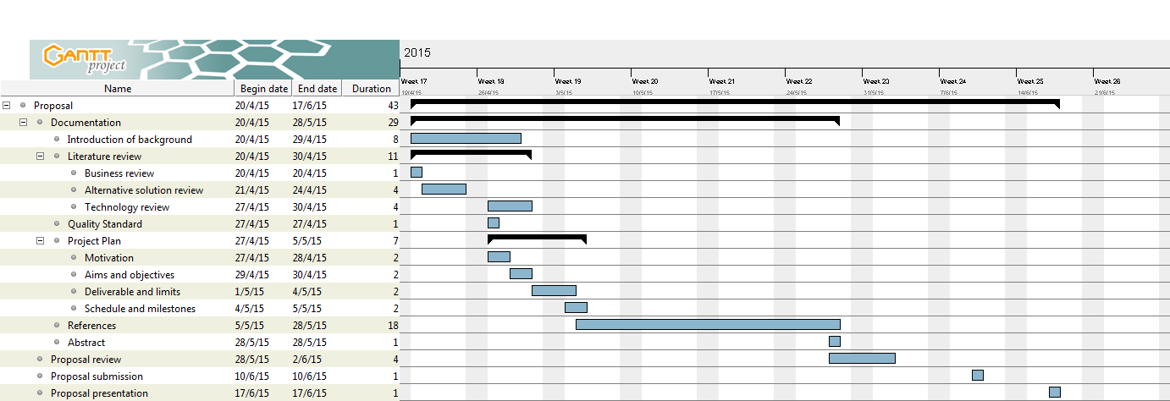**5.2 Milestone** Figure02 : Schedule and milestone

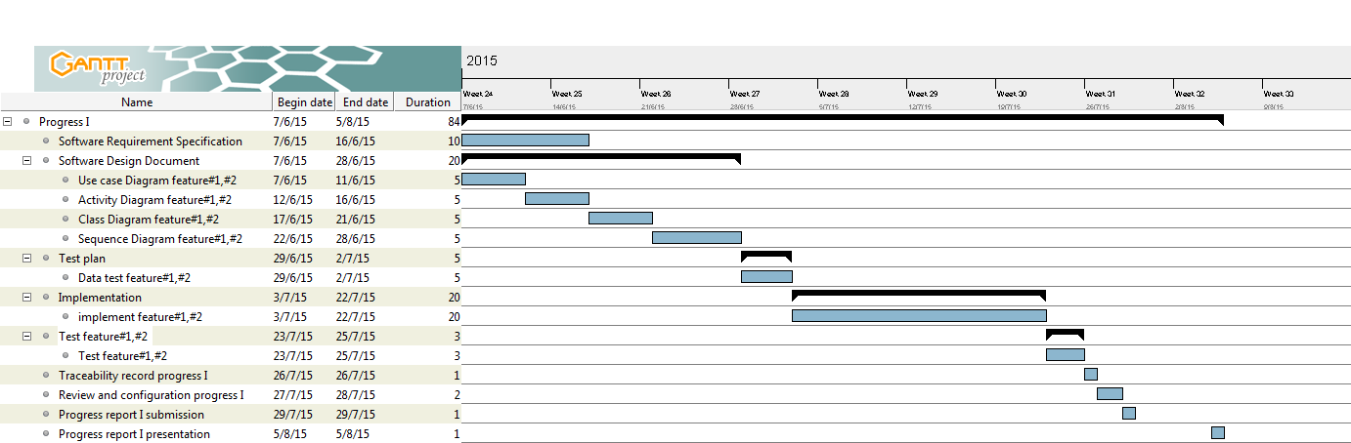**5.2.1 Progress I** Figure03 : Schedule and milestone progress l

**5.2.1 Progress ll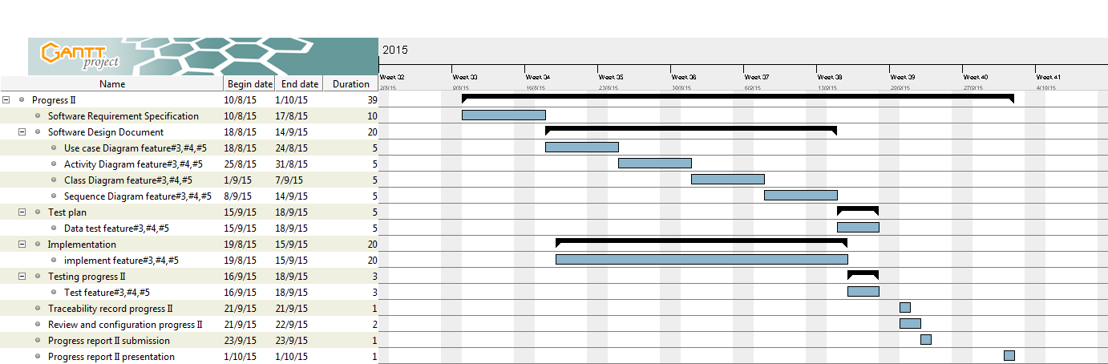 Figure 04: Schedule and Milestone Progress ll**

**Chapter Six | Software Configuration Management**

**6.1 Software Configuration Management**

Software Configuration Management is a set of activities designed to control changed by identifying the work product that are likely to change establishing relationship among them, defining mechanisms for managing different versions of these work products, controlling the changes imposed, and auditing and reporting on the changes made. In other words, SCM is a methodology to control and manage a software development project.

**6.2 Filename Format**

For the filename format that we are using for all project documents are:

ORP-[Document name] _ [Version].file type

|  |  |  |  |  |  |
| --- | --- | --- | --- | --- | --- |
| No. | Item | File Name | File Type | Path | Baseline Version |
| 1 | Project Proposal | ORP_ProjectProposal_v.2.0 | .docx | C:\ProjectSE\Proposal | 2.0 |
| 2 | Project Plan | ORP_ProjectPlan_v.2.0 | .docx | C:\ProjectSE\Project Plan | 2.0 |
| 3 | Software Requirement Specification | ORP_SRS_v.2.0 | .docx | C:\ProjectSE\SRS | 2.0 |
| 4 | Software Design Document | ORP_SDD_v.2.0 | .docx | C:\ProjectSE\Software Design | 2.0 |
| 5 | Test Plan | ORP_TestPlan_v.2.0 | .docx | C:\ProjectSE\Test Plan | 2.0 |
| 6 | Test Record | ORP_TestRecord_v.2.0 | .docx | C:\ProjectSE\Test Record | 2.0 |
| 7 | Traceability Record | ORP_TraceabilityRecord_v.2.0 | .docx | C:\ProjectSE\Traceability Record | 2.0 |
| 8 | Software Source Code | Online_Residence_Portal_v.2.0 | .zip | C:\ProjectSE\Source Code | 2.0 |
| 9 | 30 seconds Video | ORP-ShowProVideo | N/A | C:\ProjectSE\Video Presentation | 2.0 |
| 10 | Poster Size A1 | ORP Poster | N/A | C:\ProjectSE\Poster | 2.0 |
| 11 | Software Product | Online_Residence_Portal_v.2.0 | .zip | C:\ProjectSE\Final Product | 2.0 |

**Chapter Seven | Risk Management**

Risk management is concerned with identifying risks and drawing up plans to minimize their effect on the project. A risk is the probability that some adverse circumstance will occur. -Project risks affect schedule or resources. -Product risks affect the quality or performance of the software being developed. -Business risks affect the project team during developing or procuring the software. To identified risks at the start of the project and at the start of the development phase. All identified risks are documented and assessed in the Risk Management Process by the Project Team. In the Risk Management Process defines the possible risks and solution of them, and who is responsible for

**7.1 Risk Management Process**

Risk Monitoring

Risk Planning

Risk Analysis

Risk Identification

Risk Avoidance and contingency plan

List risk

Priority risk

List risk

Figure 05: Risk Management Process Model

1. Risk identification: identify project, product and business risks.

2. Risk analysis: Assess the likelihood and consequences of the risks.

3. Risk planning: Draw up plans to avoid or minimize the effects of the risks.

4. Risk monitoring: Monitor the risks throughout the project.

**7.2 Risk Identification and Solution**

|  |  |  |
| --- | --- | --- |
| No. | Risk Statement | Risk Solution |
| 1 | The requirement might be changed anytime | -Meeting and discuss and do a priority of changed requirements.  -Design system with changed requirements and related with the other requirements. |
| 2 | Team member maybe get sick or accident and can’t develop the project. | -Assign a work to another team member who doesn’t get sick or accident. |
| 3 | Work products might be not submitted on time. | -Establish the project plan.  -Develop project follow the project plan. |
| 4 | Team member does not has knowledge in some aspect for a apart of project development | -Take more class and training.  -Take more study material about that aspect. |